Homework Nr.3
There are so many interesting places to see. Imagine that you want to go travelling instead of boring studies. Get some information about Latvia and neighbor countries. Prepare answers for these questions in the language you study and who knows, maybe make a small trip
Question | Answer
What countries does Latvia have borders with?
How much does it cost to get to your country by bus/train/plane/ferryboat?
Which transport do you prefer for travelling?
Have you ever hitchiked during travelling?
Do you know anything about your country’s largest cities? Which of them should we visit?
Where should we go to a picnic?
Have you been in the House of the Blackheads?
Do you want to participate in an event „The night of museums”?
Latvia is famous for its forests. Can you name some of these forests?
Do you know which cities in Latvia host the most popular summer festivals? What music festivals and carnevals do you have in your country?
If we go to your country, near which place should we make a photo?
These keywords may help you:
Euro, lats, yens, bike, car, plane, ufo, own feet, autobahn, Tervete, Pokaiņi, Latgale, Summer Sound, Positivus, Zvērā, Pīlādzis, Statue of freedom, McDonalds, University building…
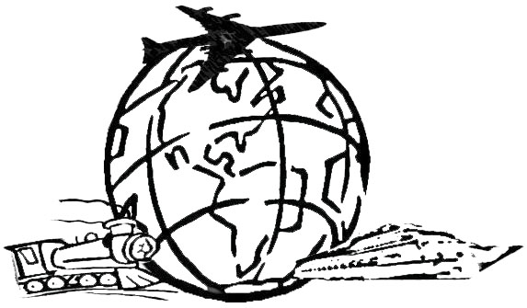
Have fun!
Your CLP Team.

